User manual – G.U.A.R.D

Version 1.1



Contents

1. Login 4

1.1. Registered G.U.A.R.D user 4

1.2. New to G.U.A.R.D 4

2. Connect to G.U.A.R.D 4

2.1. Bluetooth connection 4

2.2. Wi-Fi connection 4

2.3. Reconnect 4

3. Main screen 5

3.1. Manual control 5

3.2. MAP 5

3.3. Logout 5

4. Shortcut bar 5

5. Manual control 6

5.1. Analog controller (joystick) 6

5.2. Video stream 6

5.3. Parking sensors 7

5.4. Battery indicator 7

5.4.1. Battery detailed information 7

6. MAP 8

6.1. FollowMe 8

During the development of G.U.A.R.D, usability has been one of the developer team’s highest priorities. G.U.A.R.D’s entire user-interface is constructed in such a way that a new user shall feel both comfortable and confident using the application after only a few minutes. This manual will, however, explain each feature and function in G.U.A.R.D to ensure that all users, regardless of technical competence and interest, can use G.U.A.R.D as flawlessly as intended. The manual is organized in such manner that the user can either choose to read it from top to bottom, or use the table of content to find certain areas of the application that he or she wishes to get extra familiar with.

# 1. Login

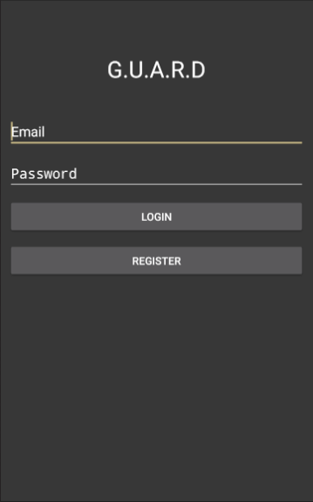When the application is launched for the first time (or if the user chooses to log out), he or she must first login before gaining access to the application.

## Registered G.U.A.R.D user

In case the user already has a registered G.U.A.R.D account, he or she may enter their credentials and press “login”, see *Figure 1* to the right.

## New to G.U.A.R.D

However, if the user has yet to create an account, he or she must go through the registration process to gain access to the application. The user simply presses the register button, see *Figure 1* to the right, and another view is shown where the user is asked to enter e-mail and password. *Notice that the password must be of at least 8 characters.* When the registration is done, the user is a registered G.U.A.R.D user and logs in accordingly (see 1.1 Registered G.U.A.R.D user above).

# Connect to G.U.A.R.D

Figure 1 – view of login screen

G.U.A.R.D utilizes two connections to work as intended; Bluetooth and Wi-Fi. The Bluetooth connection handles the data exchange between the G.U.A.R.D device controller unit (the Arduino) and the mobile device while the Wi-Fi connection handles the data exchange between the device’s advanced controller unit (Raspberry Pi) and the mobile device. For optimal user experience, both connections are recommended when using G.U.A.R.D. *Absence of either connection will disable certain features and they will appear unclickable in the application.*

## Bluetooth connection

When login has been cleared, a dialog appears asking the user if they want to enable Bluetooth. If the user chooses yes (recommended), a Bluetooth connection between the mobile device and the G.U.A.R.D device will be established.

## Wi-Fi connection

When login has been cleared, a dialog appears asking the user if they want to enable Wi-Fi. If the user chooses yes (recommended), a Wi-Fi connection between the mobile device and the G.U.A.R.D device will be established.

## Reconnect

If the user chooses to not use any of the connections, some functions will, as mentioned, be unavailable. The use can, however, at any given point use the reconnect button, see *Figure 2* below.

# Main screen

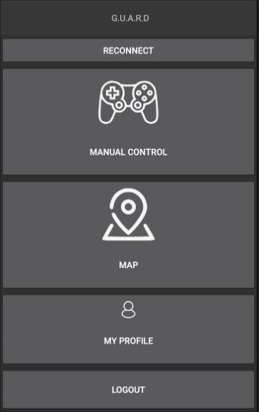When the user has logged in and cleared the connection dialogues, the user is greeted by the main screen, see *Figure 2* to the right*.* The main screen contains various options. Clicking on of the options will redirect the user to the view of such choice.

## Manual control

Manual control allows the user to control the car manually with help of a joystick. A video stream as well as “parking sensors” are provided to aid the maneuvering of the G.U.A.R.D device. See *4. Manual control* for more information.

## MAP

MAP has two usable features; a map showing both the user’s and the G.U.A.R.D device’s location as well as the possibility for the user to activate the autonomous following. See *5. MAP* for more information.

Figure 2 – view of main screen

## Logout

If the user wants to logout from the application, the button “LOGOUT”, see *Figure 2*, will do just so. After the user has logged out, the login screen is prompted and the user has to login again to gain access to the application.

# Shortcut bar

In all views, but main and login screen, a bar with shortcuts is available at the bottom of the screen (see *Figure 3* below). The bar is intended to increase the usability of the application by providing a quick way of changing view. Pressing one of the shortcuts in will simply redirect the user to the chosen view.

# Manual control

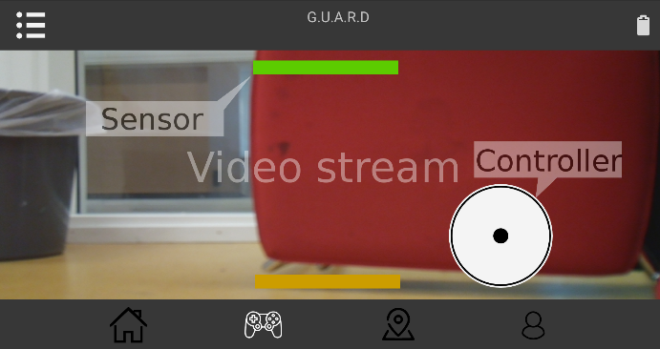The manual control feature provides the user with an intuitive way of controlling G.U.A.R.D (see *Figure 3* to the right). A digital multi-axis controller that mimics a good old fashioned analog joystick provides the user with the ability to easily maneuver G.U.A.R.D. A in real time video stream shows what is in front of the G.U.A.R.D device. To further provide the user with tools for maneuvering the G.U.A.R.D device in a safe manner, “parking sensors” which graphically indicate potential objects surrounding the device, are present in the manual control view. *Notice that an established Bluetooth connection is required for the controller and parking sensors to work while the video stream requires an established Wi-Fi connection to work.*

Figure 3 – view of manual control

## Analog controller (joystick)

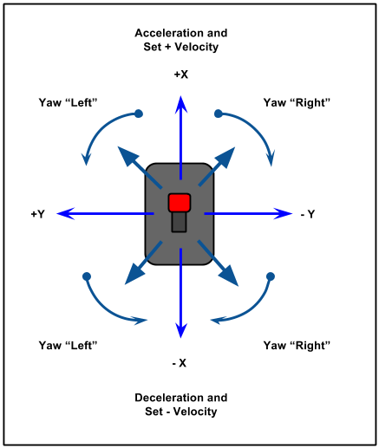The analog controller works exactly as its physical equivalence (see *Figure 3* above, white circle in bottom left corner). Pressing and holding the joystick forward will make the G.U.A.R.D device drive forward. Likewise, pressing and holding the joystick in any other way, the device will turn/drive towards the heading the joystick points at (see *Figure 4[1]* to the right for graphical guidance). The speed of the G.U.A.R.D device is directly proportional to how far the joystick is held from its center. Thus, holding the joystick as far as possible from the center, maximum speed from the device is requested. Letting go of the controller makes the joystick to automatically regress to its default position, in the center of the controller, and the device stops.

## Video stream

Figure 4 – graphical representation of how the analog controller functions

The background of the manual control view (see *Figure 3* above) is a real-time video stream facing the front of the G.U.A.R.D device. *Notice that depending on the performance of the mobile device running the application, a slight delay may be present*

## Parking sensors

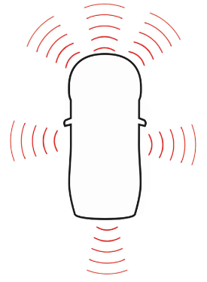The colorful lines in the manual control view (see *Figure 3* above) are the so-called parking sensors. The G.U.A.R.D device utilizes various ultrasonic sensors, placed according to the sketch (see *Figure 5* on the right). Each sensor sends and retrieves “beams” like the figure suggests and returns the distance to a potential obstacle within the beam area. If a sensor returns a number within a certain threshold, a line that overlays the manual control is shown. The color and the position of the line indicates how close the sensors senses that an obstacle is. The color changes between green and red. The redder the color gets, the closer the sensed obstacle is (see *Table 1* below for a key that shows which color corresponds to which distance range).

Figure 5 – sketch over how the parking sensors are positioned

Table 1 - table showing approximate distance between G.U.A.R.D device and obstacle depending on parking sensor color

|  |  |
| --- | --- |
| **Color** | **Approximate distance to obstacle in centimeters** |
| Green | 17 – 30 |
| Yellow | 12 – 16 |
| Orange | 7 – 11 |
| Red | 0 – 6 |

## Battery indicator

The manual control also contains a battery indicator in the top right corner (see *Figure 3* above). The indicator simply gives an indication of how much battery there is left in the G.U.A.R.D device’s battery pack. In case of critical low battery level, the application will both notify the user via a toast as well as a notification.

## Battery detailed information

The user can acquire additional details of the battery level by pressing the battery indicator which will prompt a view containing information such as estimated battery pack voltage.

# MAP

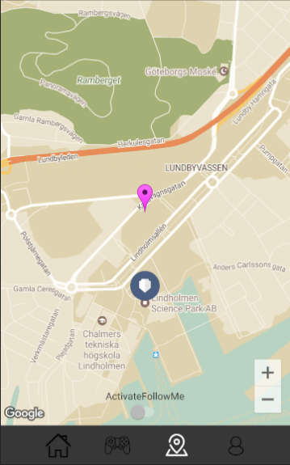The MAP view shows where the user is by overlaying the map with the magenta colored marker, see *Figure 6*. The G.U.A.R.D device, however, is marked by the G.U.A.R.D logo.

Figure 6 – the MAP view

## FollowMe

In the center of the bottom of the map, the user can activate FollowMe mode by pressing the switch. FollowMe makes the car follow the user autonomously. Thus, the user can simply click the switch and the car will start follow the user until FollowMe is deactivated, by pressing the switch once again, or when the user exits the MAP view. *Note that the car will pause the autonomous following if the GPS accuracy is too poor to support the following.*

1. Image showing two different ways of configuring a joystick. Digital image. Imgur: The Most Awesome Images on the Internet. N.p., 3 Dec. 2013. Web. 10 May 2017. <http://imgur.com/cVHe5Tr>.